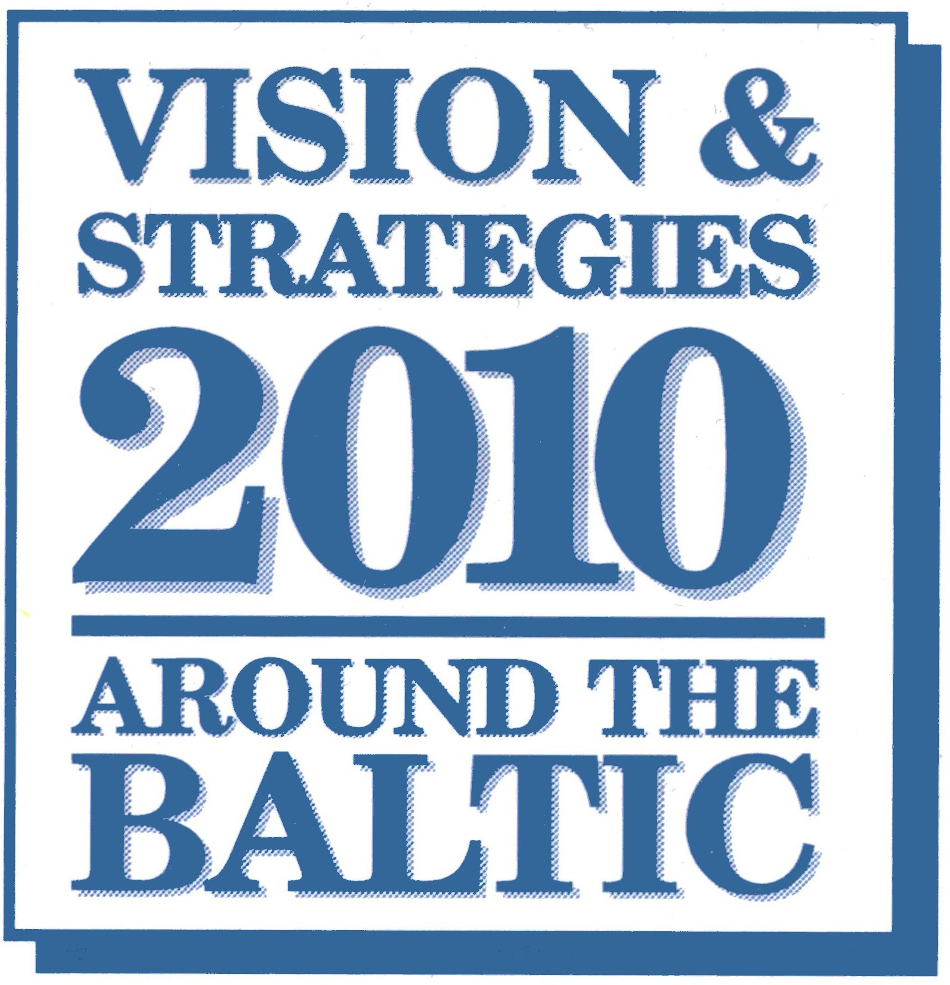 | Committee on Spatial Development  of the Baltic Sea Region  chairman
Helsinki, January 31, 2003
Mr Tauno Pesola
Ambassador-at-large
Chairman of the
Committee of Senior Officials,
Council of the Baltic Sea States

RE: Input to Preparation of Northern Dimension Action Plan, 2004-06

Dear Ambassador Pesola,

On behalf of VASAB I would like to express my sincere thanks for an opportunity to contribute to preparation of the NDAP for 2004-2006. Your invitation was strongly welcomed by the Committee on Spatial Development in the Baltic Sea Region (CSD/BSR) at its meeting in November 2002 and immediately the Committee started discussion on a general concept of our contribution and priority projects to be proposed.
Our main contribution to the Northern Dimension Action Plan is VASAB 2010 PLUS Spatial Development Action Programme, adopted at the V Ministerial Conference in Wismar, in September 2001. The Programme was concerted with CBSS and all pan-Baltic organisations and Report containing Wismar Declaration and VASAB 2010 PLUS SDAP was widely distributed, first of all to all regional authorities and larger municipalities. During the II NDAP period 2004-2006, the implementation of VASAB 2010 PLUS will be the most essential task of the Committee.
We would like very much if that Programme was recognised by CBSS CSO as one of the main important guide-posts for the new NDAP implementation in the year 2004-2006.
Your letter of 20 December was distributed among all CSD members and the Committee continued the discussion (on e-mail) on our priority actions and projects for the new NDAP.
The result is the list below with several transnational actions we would like to see in the Action Plan, differing with regard to their scope, transnationality, duration and extend of implementation achieved so far.
Since specificity of spatial planning and long term experience have proved that in this field of policy making a unique uniform solution, which might be applied as a tool-kit to different problems and situations, does not exist, we have decided to propose you different type of spatial development actions to be included to the next NDAP. Some of them are very concrete and tangible with easily seen quantitative results, some others are more general, looking forward and of more qualitative nature (e.g. laying foundations for future more concrete actions and projects). But all of them I would consider important for the territorial cohesion of this part of Europe and I can ensure you that VASAB members are ready to take responsibility for their implementation.
Therefore, I would like to ask CBSS to consider inclusion of following spatial actions and projects to the NDAP 2004-2006:

- Referring to priority 4.2A Human Resources and Education and 4.4 Cross-Border Co-operation and Regional Development we propose an “East-West Forum Project” - establishing preconditions for better participation of the Russian regions in BSR transnational spatial development cooperation and projects. The project was discussed by the CSD and currently an application to TACIS and INTERREG is under preparation by the prospective project partners (from all the BSR countries). The TACIS supported part of the Project has Russian spatial planners training and institutional building as dominating activity (priority 4.2A). The INTERREG III B is supposed to support harnessing newly established excellence centres for spatial planning and development in North West Russian Regions to effective cooperation with other neighbouring regions around the Baltic in spatial planning projects development and implementation (priority 4.4)
- Referring to priority 4.1. Economy, Business, Infrastructure we propose an INTERREG III B project named “South Baltic Arc”, especially its part concerning Via Hanseatica transportation corridor integrating Kaliningrad region into the TEN of enlarged EU, to be hopefully supported by TACIS.

Referring to priority 4.4 Cross-Border Co-operation and Regional Development we propose an INTERREG III B project BALTCOAST especially its part (subproject) “The Vistula Lagoon / Baltijsk Spit - common vision and ways of harmonisation different demands”. The Project aims at demonstrating practical ways how to simultaneously promote development and protection, making the ICZM approach more effective and extended onto areas with dynamic economic development, and introducing integrated spatial planning for offshore areas in the region. It’s based on concrete subprojects operating at the local and regional level with the involvement of different actor groups, for which applications in Eastern Europe are still needed. The Project is led by Ministry of Labour and Construction of Mecklenburg-Vorpommern (Germany) and covers the coastal, as well as offshore, areas all over the Baltic Sea (especially in Denmark, Germany, Finland, Poland, Sweden, Latvia, and Estonia). BALTCOAST intends to make recommendations for further development of the ICZM methodology and to propose integrated use strategies for the region.
The Vistula/Baltijsk Spit part of the Project has not been started yet and it is just being prepared by the Polish and Russian side with participation of Mecklenburg-Vorpommern as a leader of the Baltcoast project. A description of the project will be delivered in two weeks time.
- Referring to priority 4.2. Human resources, education, scientific research and health (and priority 5.2 The Arctic) we propose Exchange of expertise and common training courses for spatial planners with focus on specific and often harsh Northern climate. (The sparse settlement structure and vulnerable nature are some of these spatial Northern characteristics which definitely differ from the conditions in Central Europe). This project is in preliminary phase and needs further conceptualization by the authors.

Among the other transregional and transnational cooperation projects in spatial planning and development domain, we would like to mention two actions of bilateral Finnish-Russian partnership on Restructuring of North-West Russian mid-sized and small towns (priority 4.1A) and on Improving water quality in cross border cases (priority 4.3).
The first Project aims at revitalization to keep polycentric urban structure of this part of Baltic Sea Region. The second Project aims at effective cooperation in land use planning on both sides of the Finnish-Russian border.

Sincerely yours,

Ulla Koski

